Siuko Anastasiya PM-181

Web Store. The Administrator shall maintain the product catalog. The client makes a reservation and pay for goods. The administrator can bring defaulters in the "black list"

**Results of the program**

* When the program asks "Do you want to add something?" and you choose "no" in the MySQL Workbench you need to enter the commands:

**1.create table firstdb.res as select ih.* from firstdb.catalog ih join firstdb.buy jh on ih.id=jh.id;//**creates a table where information about the product you selected is recorded

**2.create table firstdb.sum as select sum(price) from firstdb.res;//**creates a table where the amount of your order is recorded

* If you did not pay for the order your first and last name are recorded in the table “blacklist”

Table “catalog”

|  |  |  |
| --- | --- | --- |
| 1 | Chanel №5 | 10000 |
| 2 | Dune(Dior) | 15500 |
| 3 | Climat(Lancome) | 6000 |
| 4 | Poison(Dior) | 4500 |
| 5 | Allure(Chanel) | 2999 |
| 6 | Pure(DKNY) | 5673 |
| 7 | Noa(Cacharel) | 1200 |
| 8 | J'adore(Dior) | 123000 |
| 9 | Envy(Gucci) | 3456 |
| 10 | 1881(Cerruti) | 8000 |
|  |  |  |

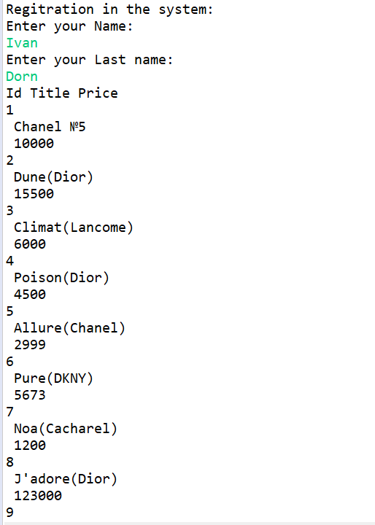

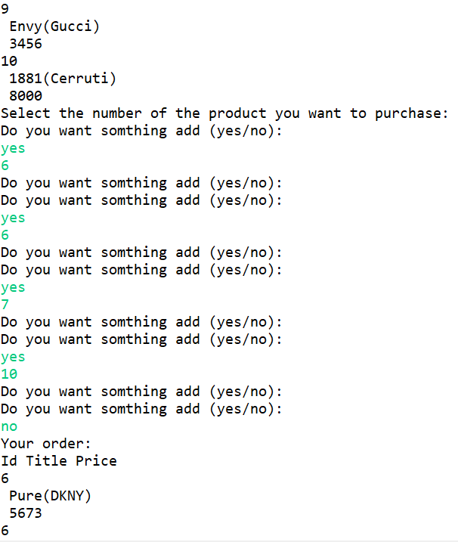

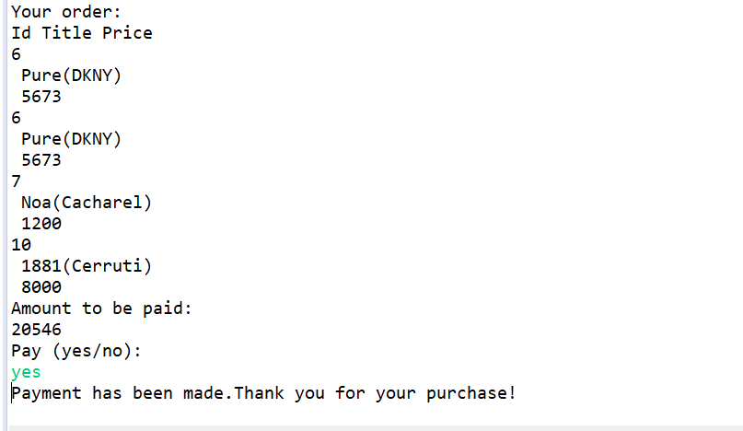

At the end when the order is paid (not paid) in the MySQL Workbench you need to enter the commands

**TRUNCATE TABLE firstdb.buy;**// clears the table where the numbers of the products you selected are entered

**DROP TABLE firstdb.res;**//destroys the table that contains information about the products you selected

**DROP TABLE firstdb.sum**;//destroys the table that contains information about the amount of your order

Table “**buy**”.Product numbers are recorded here

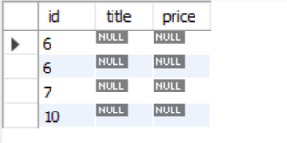

Table “**res**”.The table where information about the product you selected is recorded

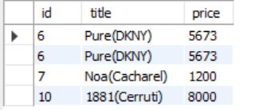

Table “**sum**”.The table where the amount of your order is recorded

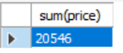

Table “**blacklist**”.

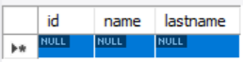

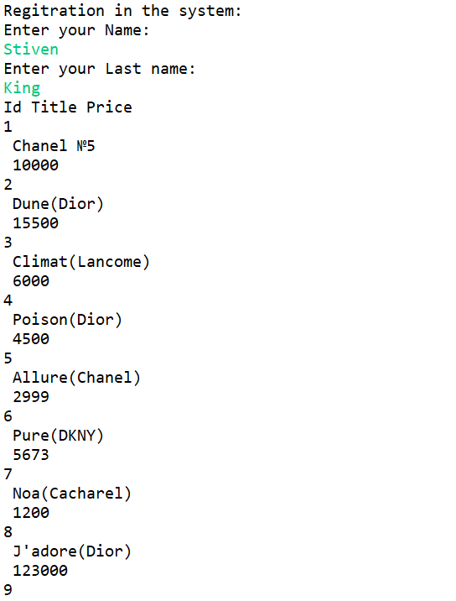

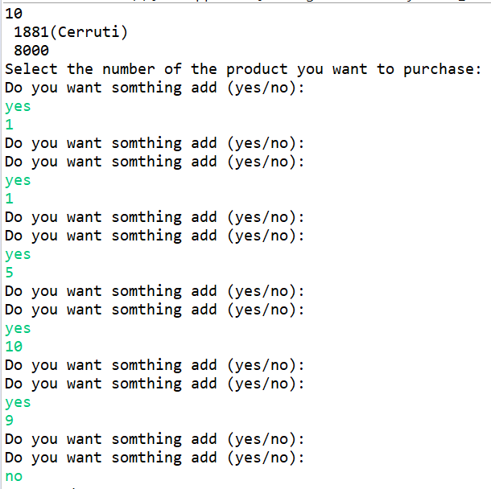

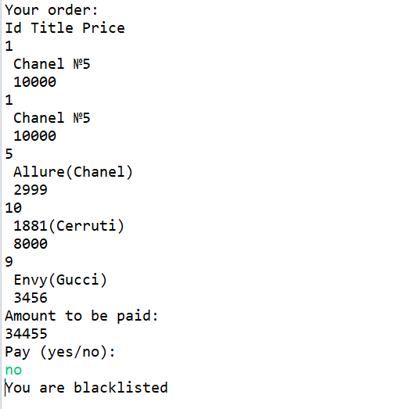

Table “**buy**”.Product numbers are recorded here

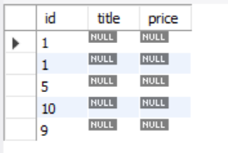

Table “**res**”.The table where information about the product you selected is recorded

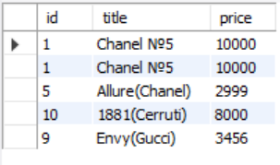

Table “**sum**”.The table where the amount of your order is recorded

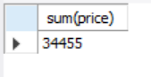

Table “**blacklist**”.

